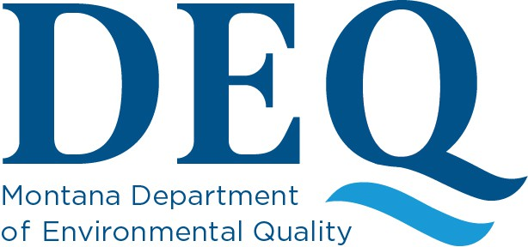

Application Payment Methods
The Asbestos Control Program (ACP) has received Asbestos Project Permit/Demolition Acknowledgment applications and payments in various formats. ACP has experienced issues with inconsistent application methods and payment processing. The goal of this policy is to ensure efficient and timely processing and issuance of Project Permits and Demolition Acknowledgments. Starting immediately, only fully completed applications with a veriﬁed payment of the correct amount will be accepted and will initiate the NESHAP 10-day waiting period.
See the only accepted methods below:

Method 1: Online Application
The most efficient method of applying for Project Permits and Demolition Notiﬁcation is through our Asbestos Project Permit Application Service. Applications that have all required ﬁelds completed and the appropriate fee paid through this website are considered complete. The application service will generate an email stating that the application has been received and is being reviewed. If you do not receive an email, it is possible that your application may not have been processed. Please contact ACP to conﬁrm the program has received all the necessary information.

Method 2: Hard Copy and Payment Portal
Applicants may submit a hard copy application and make payment electronically through the DEQ Payment Portal. A PDF application for hard copy submittal may be found on our website. A PDF application may be delivered in person, emailed, or mailed to ACP. It is critical that all ﬁelds in the applications are completed. Any applications with errors will not be considered complete until these issues are addressed.
Payments made through the DEQ Payment Portal are accepted. However, this payment system is not speciﬁc for ACP use. If the DEQ Payment Portal is used, the applicant will be required to calculate the correct fees and provide veriﬁcation of the payment to ACP by sending a copy or screenshot of the electronic receipt to deqacponline@mt.gov. A guide for submitting online payments is available on our website.
Applications will only be considered complete when ACP has received both a completed
application and the payment veriﬁcation.

Method 3: Hard Copy and Check
Applicants may submit a hard copy application and pay with a check. A PDF application can be found on our website. These can be delivered in person, emailed, or mailed to ACP. It is critical that all ﬁelds in the applications are completed. Any applications with errors will not be considered complete until these issues are addressed.
Checks must be made out to: DEQ ACP. The applicant will be required to calculate the correct fees. Applications will only be considered complete when ACP has received both a completed application and a check for the correct amount.
Please contact ACP if you any questions,

Thank you,

Montana DEQ Asbestos Control Program Phone: 406-444-5300
Email: deqacponline@mt.gov

